Had an issue with a link on the Case 03 reading materials… had to call the college and the tech department got it resolved.

Had to install JDeveloper… took about 1.5 hours

Setting environment variables

***ORACLE_HOME*/jdbc/lib/ojdbc5.jar**

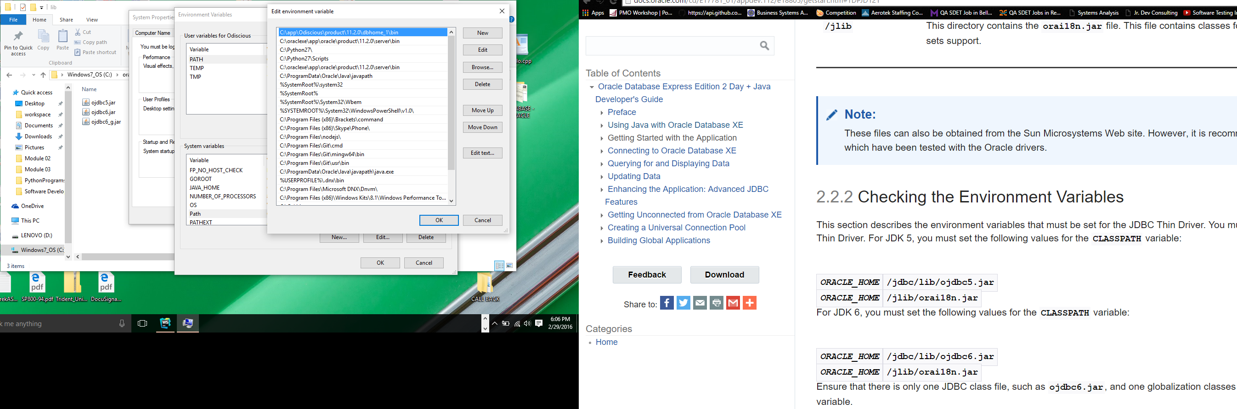

***ORACLE_HOME*/jlib/orai18n.jar**

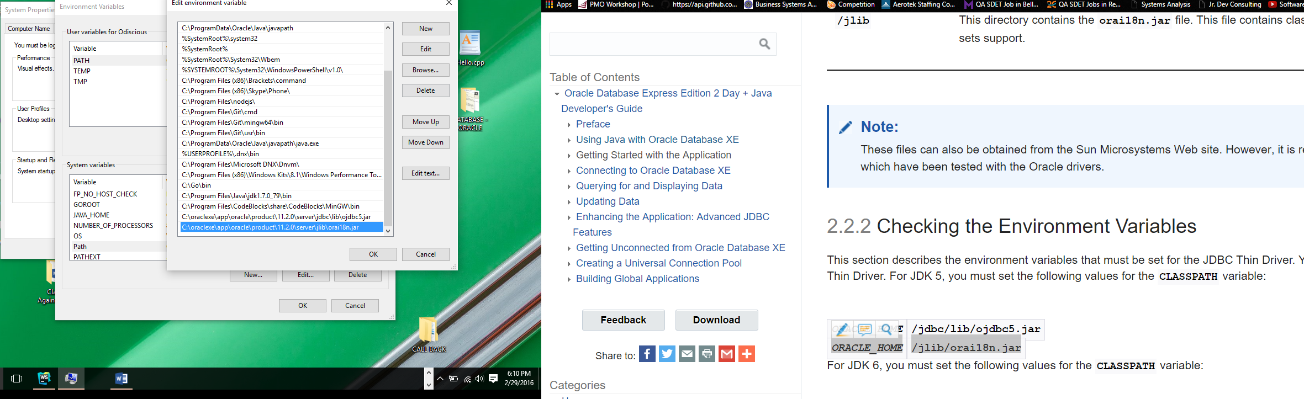

Changing to JDK6 – not sure why there’s no option for jdk8

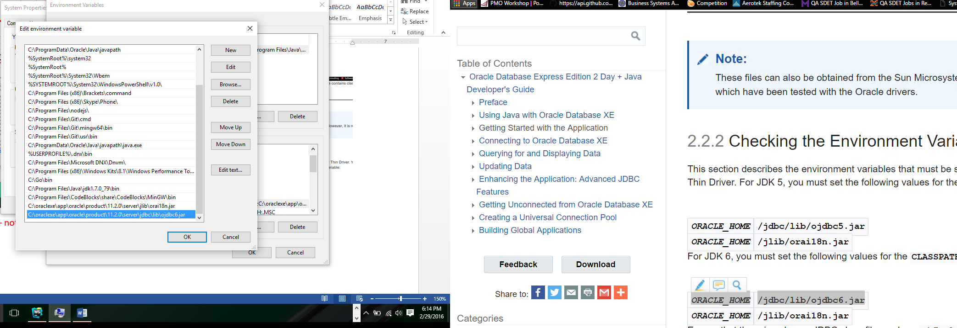

JDeveloper and Eclipse are not able to see the OracleDataSource. I’m going to attempt to restart the machine since I’ve changed the environment variables.

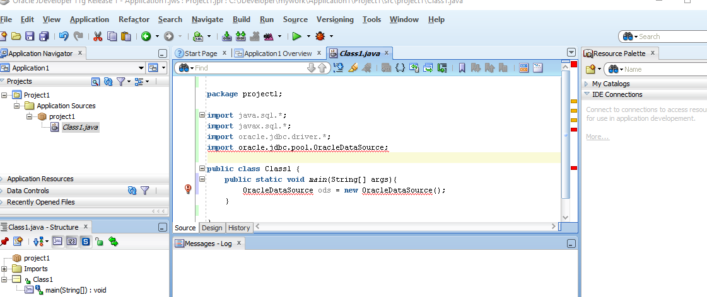

Error persists in JDeveloper although I’ve been able to fix the error in Eclipse…

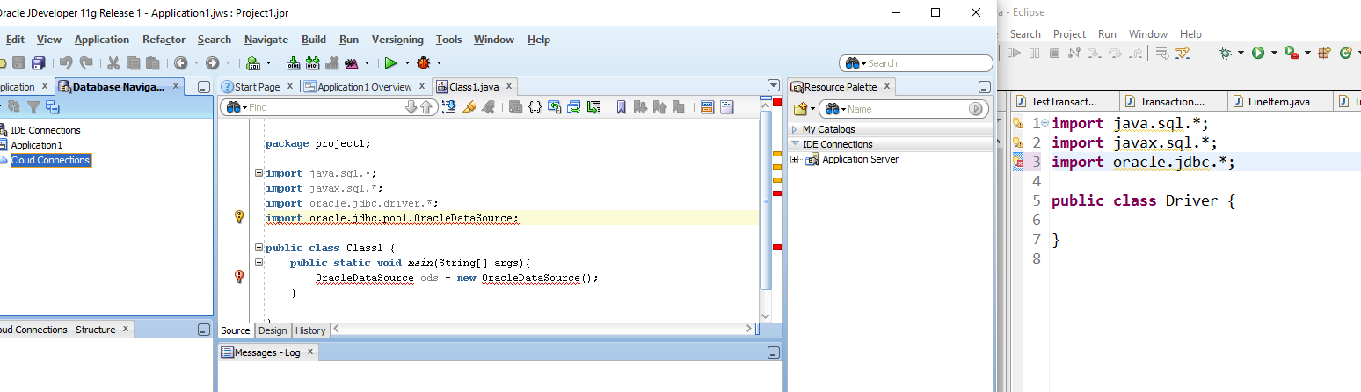

I finally got un-stuck… I was having trouble getting JDeveloper find the JDBC package. I finally was able to point the Libraries and Class path to the right directory and here is the result:

